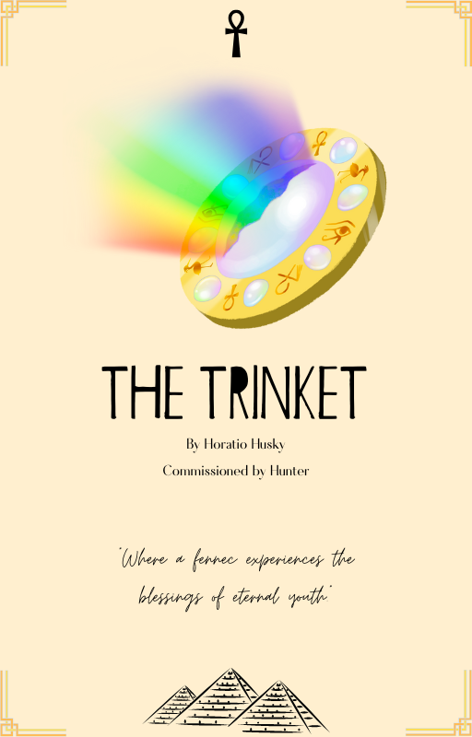

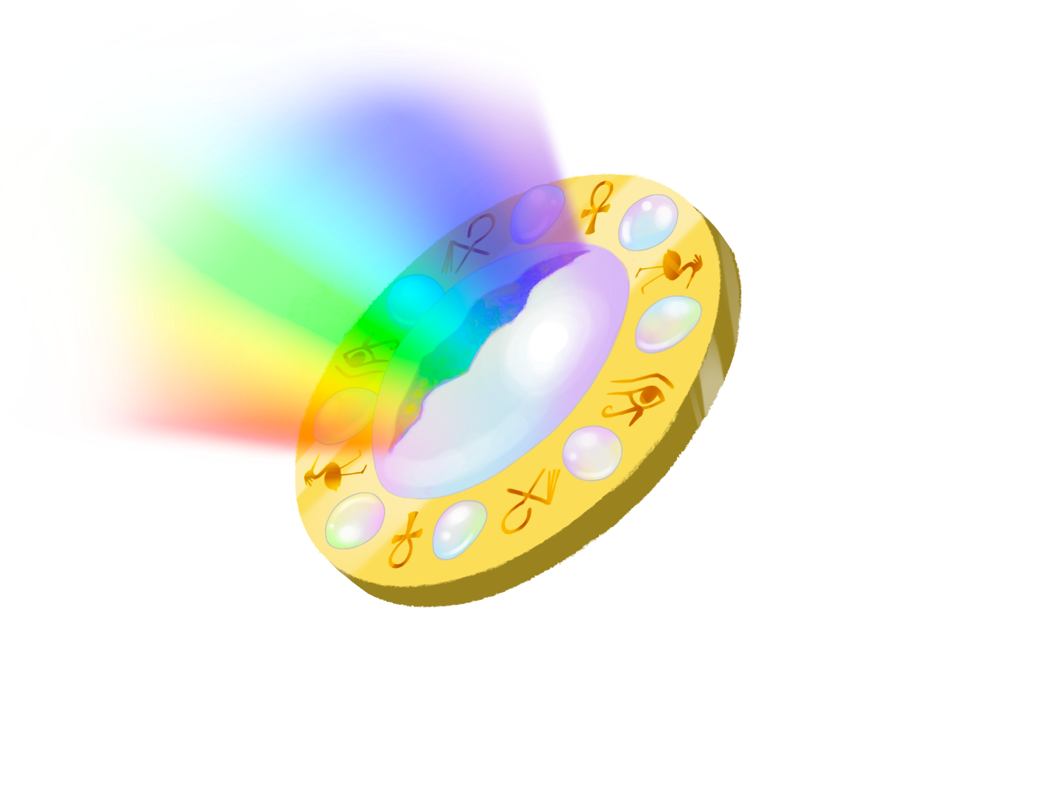

The Trinket

By Horatio Husky
Commissioned by Hunter
Written in January- of 2023
Rated 18+

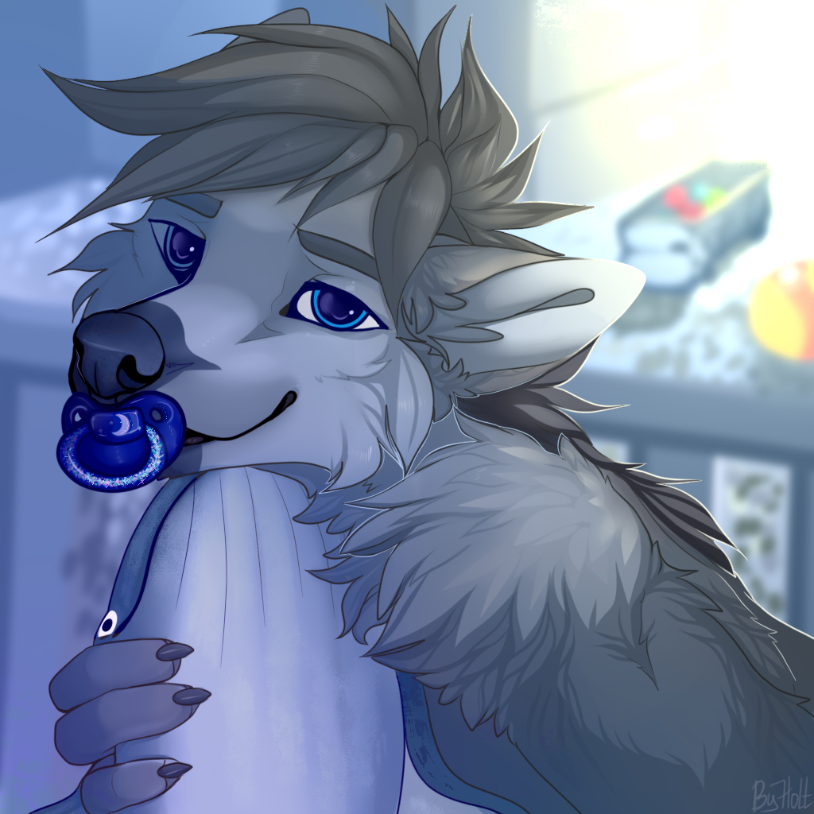

Copyright © 2023 Horatio Husky

All rights reserved. No part of this publication may be reproduced, redistributed, or transmitted in any form or by any means, including photocopy, recording, or other electronic or mechanical methods, without the prior written permission of the publisher, except in the case of brief quotations embodied in critical reviews and certain other noncommercial uses permitted by copyright law. For permission requests, write to the original author, addressed “Attention: Redistribution Request,” at the provided author’s website.

Any references to historical events, real people, or real places are used fictitiously. Names, characters, and places are products of the author’s imagination.

Published on FurAffinity, in the United States of America.

Front cover image by Kaito.
Book design by Horatio Husky.
Commissioned by Hunter.

www.patreon.com/horatiohusky
The Trinket
By Horatio Husky
Commissioned by Hunter

Chapter One

The Will

Hunter sighed as his mother, who he was currently on the phone with, continued to drawl about the contractual obligations he now had to abide by. His great aunt, or now his late great aunt, had left him a few things in her will that came with a few specific rules.

The fennec fox had barely known her, other than seeing her at a Christmas party and once during Thanksgiving when he was very young. She was not really even his aunt, being an in-law and a cheetah to boot. He had heard a few stories about her, some from his mother who had always spoken about her with a degree of awe mixed with disapproval. Whether or not she was even really his aunt in-law was in question sometimes, but her presence in the family was nevertheless appreciated, if not coveted.

She had been an Egyptianologist, but not the kind that mostly stays on the campus of a university. Accused several times of being no better than a bounty hunter with a college degree, she would often beguile whoever cared to listen at the taverns and bars she was often found at about her great adventures in the middle east. There were usually many stories told and drinks bought during such evenings.

Her alcoholism aside, she had apparently kept up her taste for adventuring into abandoned tombs and caves right up until the very end. They never recovered her, but enough time had passed where her body had been declared lost and her vast collection of artifacts reclaimed by the museums and universities. Judging from their hasty reclamation of such items, they had been waiting for exactly such an opportunity as her disappearance.

They had claimed most of the artifacts, at least.

“So like, dumb it down for me a bit, Mom?”

Hunter asked, a slight note of exasperation coloring his tone of voice as one of his large ears flicked to the side in irritation. It was his mother’s turn to sigh, which was followed up by a response.

“You just can’t sell any of the stuff. You’re supposed to keep it as if it were a family heirloom. There’s some evidence to support that this does belong to us give or take a hundred generations.”

Hunter replied back.

“Right, don’t sell. Just keep it. Anything else?”

“Not until they go through the rest of her possessions and check her records. You might be getting some money too, but that’ll take a while.”

Right… After the state takes its hefty cut…

Hunter thought to himself, but he did his best to keep his sense of sarcasm out of the conversation.

“Great, thanks Mom.”

“Of course honey, was there anything else you wanted to know about Auntie Tare?”

Hunter, knowing that this would probably prolong the conversation for another good hour, shook his head before realizing that his mother could not see his reaction. He cleared his throat before he spoke.

“Hrm… No, no. I think I’m good for now, still… Processing and all that. I’ll talk to you later Mom.”

“Okay sweetie, let me know what’s in the box. It looks mysterious!”

“Yeah, I will. Love you Mom.”

“Love you sweetie, bye bye now.”

The line went silent, and Hunter put his phone down on the table with a sigh of relief. As silence enveloped the apartment, interrupted only by the soft hum of the refrigerator in the kitchen, the fennec’s gaze drifted over to the box that sat in front of him on the dining room table.

The word that could describe the wooden container could only be described as ornate. Carvings of Egyptian hieroglyphs laced with what he suspected was gold lining on the borders of the miniature crate gave the appearance of a most valuable item being stored inside. The wood had been treated with oil, and with great care as well. Part of him wondered if the box might be empty, as the container itself looked relatively valuable. Whatever it was, he was not surprised that his aunt had mentioned that he was not allowed to sell it.

I’d probably make a pretty penny off of it too…

Hunter mused to himself, as he pushed his chair back and stood up, only to crouch in front of the box in order to more closely examine its decor. He was not literate in Egyptian hieroglyphs, nor was he particularly interested in learning more about them. History had always bored the little fox, and despite having a renowned, though estranged, Egyptologist in the family it never sparked the same fascination and excitement as it did in Aunt Tare.

Well, might as well have a look then.

Reaching forward, he undid the clasp on the front of the box and pushed the lid open. Its hinges worked silently, and Hunter immediately noted that the entire inside of the box was laced with a vibrant, purple velvet.

Amidst the swathes of cloth, Hunter beheld a palm sized brooch made of a mixture of dulled copper and gold. Marveling at it, the fennec’s eyes widened as he scanned its surface. The fennec picked it up with a paw and noted its significant weight. Equipped with a pin which Hunter presumed was intended to keep a cloak around a traveler’s shoulders, Hunter turned the brooch over and let out a surprised breath. The ornament had been placed upside down in its container, and it was studded with several small jewels with one large piece in its center. Peering closely at them, it took Hunter a moment to realize that they were opals.

In the center of the metal disk, the largest of the opals was oval in shape. It gleamed as if freshly polished when it caught the last of the afternoon sun streaming from Hunter’s half shuttered window. A small scratch in the center of the opal was the only blemish on the piece, revealing the rainbow colored insides of the gem that refracted in ever changing patterns of color as he turned it over.

Strangely, despite the fact that it had been sitting in the box ever since it had been delivered to his doorstep inside of its own, discrete cardboard container, the brooch was warm to the touch.

And it felt like it was getting warmer.

“It’s… pretty…”

Hunter said lamely, to no one in particular. His initial curiosity had been sated, and he was now coming to the conclusion that he really had no use for the gem-encrusted display piece other than to perhaps show it off for his friends.

The more he thought about it, being the owner of such a valuable piece now might mean
that he would have to take insurance out on it.

Great… Another responsibility…

The fennec thought grimly to himself.

Hunter was about to set the artifact down, when the opal flashed catching his eyes. Blinking, he looked down at the gem and wondered if he had imagined the sudden luminescence that had come from the piece. Gingerly, he brought it back up to his eyes and peered closely at the scratch on the gem’s surface to see if he had missed some refractive angle inside of the opal’s crack.

Seeing that there was nothing he could immediately detect, he placed the brooch back
down in its comfortable bed, this time right side up with the opal facing the ceiling of his apartment. He thought about where he should put the box, glancing around his apartment and seeing now apparent free space where he might rest it.

I’ll probably just chuck it into my closet or something…

His stomach rumbled, reminding him that his mother’s phone call had caused him to miss lunch at a reasonable hour. Closing the box, he decided to put his inheritance out of his mind for the time being. Padding over to his closet, he picked out his jacket and fumbled the keys to his apartment out of the bowl they rested in.

I’m kind of hankering for some chicken…

He thought to himself, his mind already beginning to drift away from the strange set of rocks that were now his, now and forever. He did, however, check twice that he had locked the door to his apartment before bounding down the staircase leading to the lobby of his apartment complex.

