**Joshua Forbes’s Wild and Queer Crops**

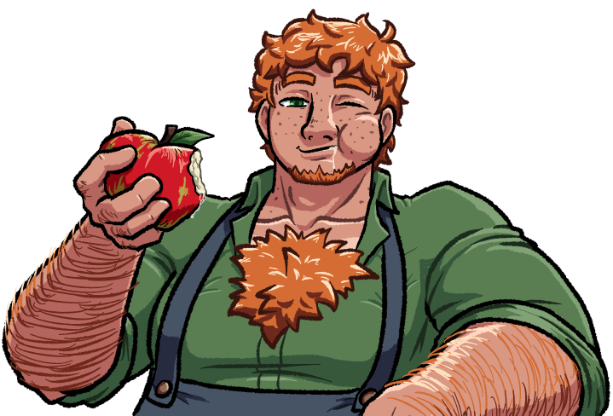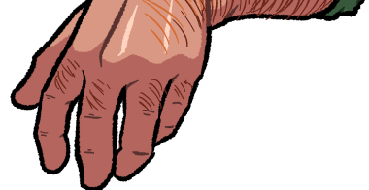

Howdy, y’all! Name’s Joshua Forbes, owner of the Northwest County’s Forbes Farms, and we’ve been in the business of supplying locally-grown fruits and vegetables to the community for a few generations now! Today, though, I’m looking to discuss some particular crops we’ve worked with on this farm that tend to get us a bit more business outside of our typical reach.

See, there are some particularly unique specimen that have been in our family’s care for quite a while, and I saw fit to put together some better documentation on them than the yellowed pages my Grampa put together during his time running the place. These are rather dangerous crops with radical effects on the human body – nothing lethal, far as we’ve discovered, but definitely some pretty dramatic effects. As a result, I have no intention on sharing the methods of growing and caring for them in these videos, instead focusing on identification and effects upon consumption. I haven’t taken to studying the exact means of how they take such effects on the body, but I can offer some basic conjecture on what might cause these effects.

That said, the effects themselves have been observed within my family for ages now! Many of the fruits of our labour naturally enter our own diets – we’re actually a mostly vegetarian family, if you can believe it – and the crops I’ve selected to show are no different. So if you need testimonies on the effects of some of our produce, look no further than yours truly, because you don’t grow *this* big and healthy without a helping hand!

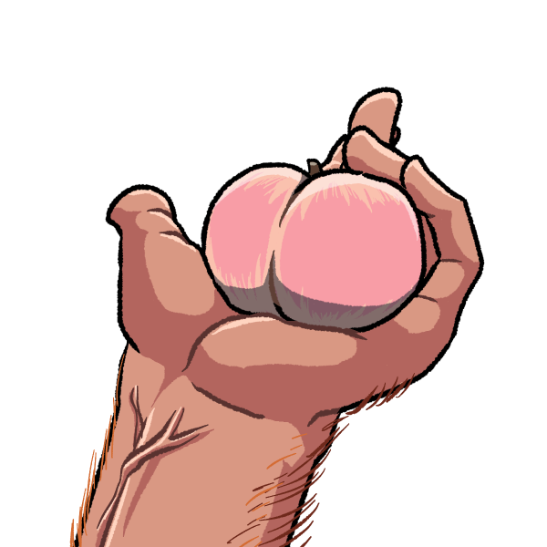

**Marshmallow Peach**

I know it doesn’t look like much in my hands, but just remember, folks: I have pretty big hands. But it should still show on camera that this here peach is pretty... well-rounded, and also has quite the sheen to it. Perhaps even more peculiar about it is how resistant it is to bruising: most stone fruit grown around here will bruise from almost any force against it, but this one can take a lot of pressure against it! Push my thumb into it for a couple seconds, release, and suddenly, that dent I pushed into it is filling itself back out again! And if I cut into it later, you wouldn’t even be able to tell where I was pressing into it; the flesh of the fruit doesn’t discolour at all!

When consumed, the peach has a dramatic impact on a person’s metabolism. I can’t say for sure if it possesses some kind of estrogen-like chemical compound, but what I can say is that it emulates some of the effects estrogen has on the body, and push them to extremes. For a day or two after eating one of these, your body starts craving for a huge amount of calories, especially in the form of fats and proteins. If you can’t give it enough, it chews away at some of the muscle and fat you’ve already got built up, but it’s very particular about where it gets it from, just as how it’s particular about where it sends the fuel you give it.

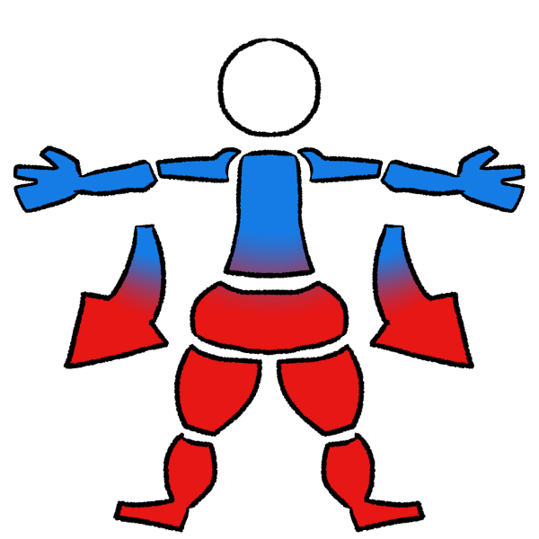

When I was growing up, I was suppose to balance my diet with this and another crop I’ll show y’all later. The marshmallow peach here is great for building a lot of the muscles of the lower body, as well as packing on weight down there as well. As a result, your upper body is neglected by the nutrients you provide for a while. Eating this bad boy swells your ass out like a balloon, and turns your thighs and calves into tree trunks, but if you don’t stuff yourself with enough calories, you might find you’re not filling out your shirts as much as you used to. Your chest starts to shrink down, and your arms get thinner, so you have to make sure to get your fill each day you chow down on these peaches.

**Heavycri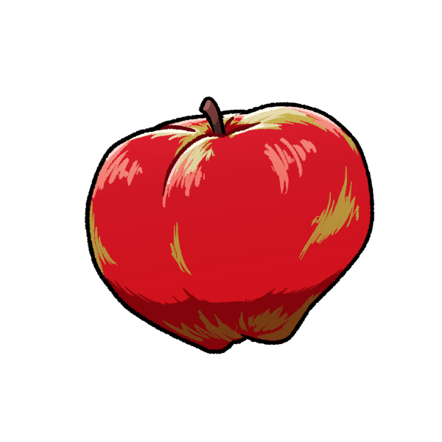sp Apple**

Actually took me a minute to find one of these; I almost can’t grow enough of them to meet the demand they get...

So this inverted pear-shape you see before you has some interesting commonalities with the Marshmallow Peach. They play a sort of yin and yang role with one another, but let’s slow down a bit and appreciate the heavycrisp on its own. Most of the fruit’s flesh seems to rise to the top, closer to the stem. It’s also a very dense kind of apple, with a lot of meat packed into its already large form: this is actually on the smaller side, but it still weighs probably twice as much as the average honeycrisp apple. It’s pretty rough eating them raw like you could do most apples; all that extra flesh is hard to chew through, so it’s easier to slice it up before serving it.



Now, if the marshmallow peach is like some kind of super-estrogen, the heavycrisp apple’s a super-testosterone, though that’s oversimplified in all directions. It is still the yin to the peach’s yang: where the peach will strengthen and fatten up your lower body, these apples shift all the focus onto your upper body, and they’re even nice enough to give your core muscles a bit of attention, too! Wolf down enough calories for a few days, and you’ll build enough muscle and fat to rip through most of your old shirts, but if you can’t get yourself enough, you might find your pants falling down without a tight enough belt.

I admit that I like the taste of the heavycrisp a bit more than the marshmallow peaches, and the extra muscle up top is more up my alley than a fat ass, but I can’t stress enough the importance of balancing out how much of each that you eat. I end up getting a lot of bodybuilders and muscle freaks clamouring for as any heavycrisps as they can carry, and they already seemed the types to skip leg day. A lot of them were used to bulking pretty hard, so some of them got the exact results they wanted, but across the board, I got calls back complaining that they were finding it harder to walk around. The increased weight you get from bulking with heavycrisps can very quicky leave you feeling less and less mobile if you don’t make sure to build your lower body muscles without their interference. So whenever I sell someone a helping of heavycrisps, I always hand them at least two or three marshmallow peaches with a note to eat them when they feel like they’re struggling on their daily runs or start feel their legs wobbling.

**Miniatu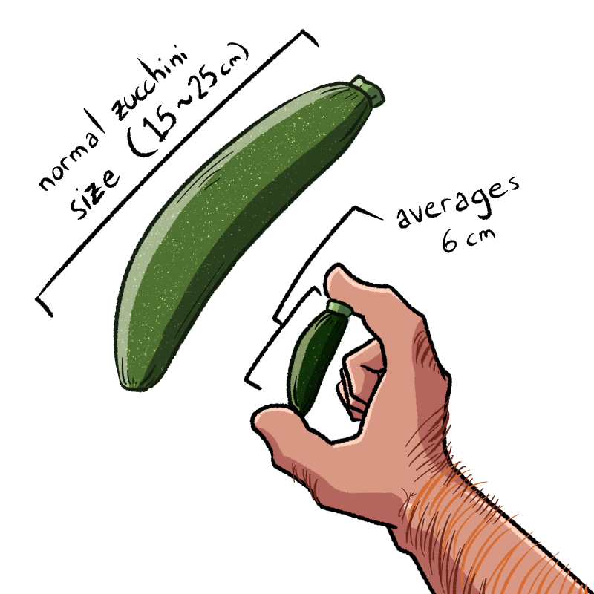re Zucchini**

This poor thing is what a lot of disgruntled housewives might see when they’re thinking of their husbands while looking at regular squash in the supermarket. Crude statement, I’m sure, but not unfounded: this miniature zucchini is less than half the length of the average zucchini, and thinner to boot. Likely a direct result of its smaller size, it has a much deeper colour, concentrating all those chlorophylls into a smaller surface area. Aside from that, though, it doesn’t stand out much physically compared to its more impressively-sized friends.

It does seem to possess a very dangerous chemical compound, though, depending on your definition of ‘danger’. As if some sort of spiteful curse, the miniature zucchini has a particular nutrient built within it that eats away at a very specific cell structure when broken down in the body. This nutrient – for some reason – only seems to target the sponge-like tissue that make up the corpora cavernosa and corpus spongiosum in the human penis, but it’s quite effective at eliminating that tissue. Within four or five hours of consuming this little bastard, you might find your own little bastard’s gotten an inch or two smaller – and that’s before you check how it looks hard!

If you can imagine, this makes the miniature zucchini the perfect tool for petty revenge or a cruel prank. Pops knew that, and made a point to bar it off from all his kids growing up. Didn’t stop my brothers from fucking around, but they found out sooner or later. I was only victim to this thing once or twice, but I found my way around the shrinkage!

That one, though, is a family secret~! We’d never hear the end of it if people figured out that one...

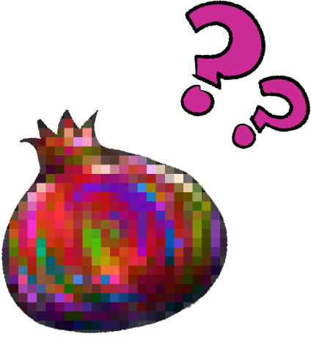

**Fruit of Knowledge**

So this here fruit’s a peculiar one: I’m not sure if it shows well on camera, but it’s very nebulous, isn’t it? There are plenty of people who’ve seen this fruit once or twice – my family doesn’t tend to let anyone eat it, if we can help it – and none of those folks seem to agree on what kind of fruit it is. The tree has leaves that look very similar to the distinct shape of fig leaves, but some people are still very convinced it’s a kind of apple or pomegranate. I’ve had someone argue to me that it’s a grape of some kind once!

I’m not gonna pull your leg on this one: it’s probably not the same fruit you hear about in the Garden of Eden, but it has a lot in common with it! I don’t have a good explanation on the why, but the skin of this fruit plays a trick on the eye, making it difficult to properly place its shape, colour, texture, so on. If you do get a hold of it, though, even the feel of it on your hands leaves you weirdly confused about what it’s meant to be. Only way to do away with that mystery is to take the plunge and bite into it!

I actually snuck a bite of one of these when I was younger, before I took the farm – Pops told me I was supposed to eat it closer to my 18th birthday, but I guess temptation got the better of me. The taste of it was both unbearably sweet and extremely tart, and it practically electrocuted my tongue, along with a few other things. There’s something within the sugars or the proteins of this fruit that put your nervous system into overdrive almost immediately after biting into it, and it starts carving out pathways in your brain that weren’t meant to be op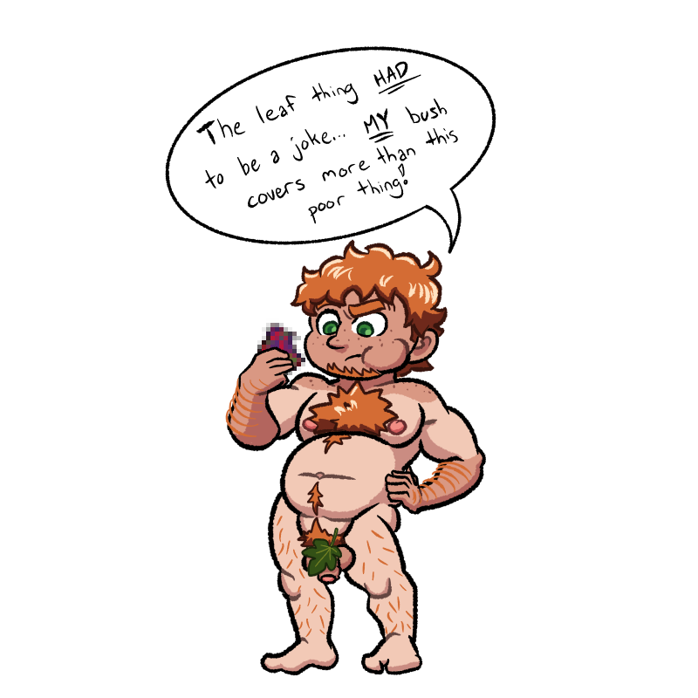ened up. It acts like a neurotoxin in that way, but one that conveniently provides its own antidote. Once you brave your way through the first bite, you just chow down on the whole thing, swallowing as much of the fruit as you can, and in an hour or two, you’re better than fine!

Once your body properly breaks down those proteins and sugars, and supplies the brain with those nutrients through the circulatory system, it starts to do two things: it calms down the initial, almost allergic response to the fruit’s juices; and then it reinforces those pathways it’s opened up, allowing your neurons to fire off safely in those zones, faster than they ever did before. Again, most of the effects I’ve discussed are all based on conjecture, because I have no intention of letting this fruit get studied and replicated, but the takeaway is that eating one whole fruit from this tree makes you insanely smart. The fruit has a hard cap on how much it can boost your brainpower, naturally; I’ve snacked on them every once in a while, and not only does the overstimulation peter out after the first couple of fruit you choke down, but after you’ve eaten maybe five of them, the brain-boost it gives tones down into a pseudo-caffeination effect.

Also, I do actually know what the fruit looks like now, but that one’s a family secret~!

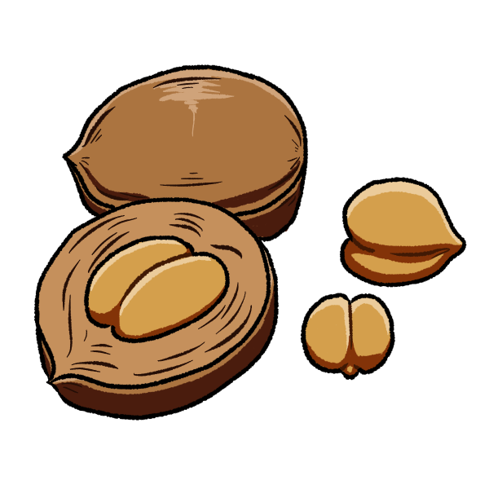**Smooth Walnut**

I’m not sure if I consider these little nuts to be more or less dangerous than the Fruit of Knowledge, but I know for a fact these things can fuck you up if you’re not careful with them. Regular walnuts tend to have a textured shell with little dimples in them around the center of it, but this here smooth walnut doesn’t have much texture at all, does it? It ain’t perfectly smooth, sure, but the surface of it is like a well sanded plank. Cracking one open, you can see the shell of the smooth walnut is twice as thick, even when it’s got the same outer surface area. Inside is a nut that looks more like two peanuts fused together, but a bit smaller. Far cry from the ridged and intricate shape a regular walnut has.

So let’s get to the reason these things can be a bit scary: my guess has a lot to do with the unsaturated fats that make up a lot of nuts and legumes, that these things have a sinister version of lurking within. See, walnuts and pine nuts are full of polyunsaturated fats, which is stuff like omega-3 and omega-6 fatty acids, which might be something you’ve heard you can get from fish and eggs. They’re quite good for the body, especially in promoting brain function, so naturally you want to get your fill of those fats, and walnuts make for a half-decent snack.

I think smooth walnuts have something that might fake the appearance of polyunsaturates to the body, and worse yet, happens to work against their primary functions. Those fake fatty acids find their way to the brain real quick, and then start clogging up neural pathways, especially around the prefrontal cortex. Eating one or two smooth walnuts don’t change your brain chemistry noticeably on their own, but you’ll probably feel a bit more ditzy for a while – I’ve done a test or two with a few willing subjects who seemed to return to mostly normal brain function after almost two weeks of ingesting three smooth walnuts. Eating more than that can have far more detrimental – and potentially permanent – effects on your brain chemistry.

I had an older brother, who was pretty quick-witted on his own, but kind of a lazy guy. He had a tendency to spend his nights lounging in the living room, watching whatever he could find on the TV, and snacking on whatever he could find in the kitchen. Pops always said it’d rot his brain one day, but probably didn’t mean... Well... No one actually knows how it happened, but one night, he ended up getting a bowl full of smooth walnuts without anyone – him, least of all – realizing it. Late in the night, I saw him on the couch, zoned out more than usual, and took a look to see a few of those bastards and their crumbs littering his chest, as this long trail of drool oozed down his chin onto his shirt.

As it turns out, shocking those pathways back open with a Fruit of Knowledge is effective in helping someone recover from eating more smooth walnuts than they intended, but it ain’t a cure-all. Poor guy doesn’t remember much from before eating those things – lost a few years of memories, in fact, and still manages to mess up our names every so often. Not as bright as he used to be, neither. Hell, on some days, you can kind of see him slip back into a catatonic state for a few seconds unprompted, probably from some fake omegas slipping into the gaps and plugging up some of his thought processes again. He’s always got a weird smile on his face in those moments, too. We have to keep him far away from those walnuts now, because every so often, he mumbles about the one thing he actually remembers from that night: apparently, these things are kinda tasty.

And – according to a good handful of fellas who were eager to try them out themselves – he’s not the only one who thought so.

So obviously, these are all crops that have to be handled with care, each with their own set of dangers present. I know some people would argue for just throwing the lot of them away before they do more harm than good, but my family didn’t spend generations cultivating these beauties – and more – just to toss that all away just because someone didn’t read the warning sign. I’ve been taking good care of my own personal collection of these plants, and give them the same love I’d give any crop – if not more! These wild and queer crops are part of my family’s legacy, and I’ll see them live on for the next generation after me.

Not to mention, there’s not a crop I’ve mentioned here that hasn’t piqued a potential consumer’s interests. Hell, long as you tell them the risks, you can find freaks willing to swallow down a whole handful of those brain-blockin’ walnuts! I’m even happy to cook them up into a nice dish for a few pals I bring home every so often~!