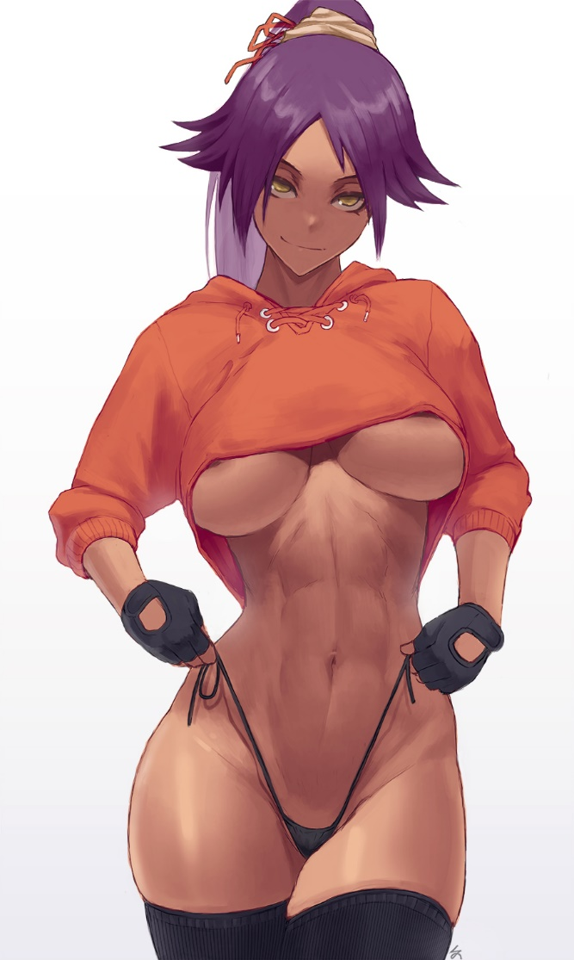

Section 1

RULE 1: Free-spirited and super fit and tanned sex pot. With a thermonuclear sex drive. Wanders around looking for fun.

RULE 2: Actually a princess from the soul society. Grew up in wealth.

RULE 3: Likes to stretch out and laze around like a cat, even in human form. Dislikes shows of wealth. Nudist with a rebellious streak.

==0==

Section 2

EXTERNAL
- Name: Yoruichi
- Age: 500ish(?)
- Gender: Female (duh)
- Race: Shinigami
- Height: 5’ 1.5”
- Body Type: Very fit hourglass. Long legs. Exaggerated TnA.
- Facial Features: I mean it’s Yoruichi, she’s just straight up hot.
- Eyesight: She’s a ninja, probably good, definitely has sharp night vision.
- Sound Of Voice:
- How They Talk: Usually laid back or just straight up flip to aggressive if she’s annoyed.
- How They Get What They Want: Flirting and/or punching things.
- Role In Story: Canonically, mentor. In these stories? Untamable fuckpet.
- Social Class/Economic Status: Born a princess but doesn’t live like one. She just wants to live however she wants outside her family.
- Employment/Education: Probably the best the Soul Society can give. Now whether she paid attention or not… who knows.
- Eye Color: Gold
- Hair Color: Purple
- Handedness: Right-handed
- Distinctive Marks: By default, none. Her skin’s pretty much perfect.
- Distinctive Skills: Motherfucking kung fu! Also very flexible ( ͡° ͜ʖ ͡°)
- Powers (if any): Super speed, lightning manipulation, typical Shinigami. Turning into a cat. Also her zanpakuto Engohime (my creation and not canon).
  - Sexy Uses For Powers: Electro play, so like prostate zapping and stuff like that. Using speed for stealth handjobs/blowjobs. Vibrating hips while a guy is inside her or grinding her. Flexible enough to sit on a guy’s face then also suck his dick while doing a backbend. Or a standing split or any of those crazy poses you see the street fighter girls doing.
- Notable Mannerisms…
  - Facial Expressions: Lots of smirking and grins.
  - Body Language: Folded arms and cocked hips. Pokes fingers together when nervous.
  - When do they do each/some/all of these things?: When she’s got one over on somebody… which is most of the time.
- Sexy Characteristics: Super fit hourglass figure
- Sexual History: Extensive and majorly slutty. Men, women, plants, you name it she’s stuck it in her.
- Hobbies: Kung Fu, Sex, Lazing Around, Curling up in sunbeams
- Living Arrangements: Either hangs out in cat mode or crashes at a friend/fuckbuddy’s house. So, homeless.
- Pets (if any): None, she IS the pet.
- Typical Outfit: Naked. Or the orange top and tight black pants she’s famous for. Prefers naked.
- She Assumes... pretty much everyone is attracted to her.
- Others Assume She… has commitment problems. Truth is she’s just looking for a man who can keep up with her.

==0==

Section 3

SEXUALITY
- What’s So Great About Them?: Sexy free-spirited fitness goddess. If you want to get in shape or expand your horizons. She’s your girl. Just get ready for her lewd pranks and lots of teasing.
- How Often Do They Have Sex? Often as she can get it with whoever she can.
- Do they Masturbate? How Often? Hell yes, at least once a day. If she doesn’t cum at least once every 24 hours she gets… antsy.
- How Much Stamina? Tons of stamina. Doesn’t mind taking the lead when her partner (inevitably) wears themselves out. If they’re cute at least.
- What Characteristics Turn Them On? Aggression in her men, especially if brought out by her. Loves to see what it takes to make a man snap and screw her into a babbling idiot.
- Kinks: Exhibitionism, Teasing, Consensual Non-consent, Size Queen (bites off more than she can chew sometimes), Muscular Guys Sweating, Blowjobs (spitting is for quitters!), Facesitting, Impregnation
- They like being touched…
  - Conventional: Ass and titties all the way, loves being petted there just like a cat.
  - Unconventional: Back of neck scratches. And also the top of her head.
- Fantasies They Fulfill: Taming a Wild Woman, Dark Skin, Public Sex, Exhibitionism, Catgirl
- Top? Bottom? Switch?: Switch but favors top. Really likes to play a teasing sub at the start and then turn the tables the second her partner tires out.
- Favorite Positions: Doggystyle and amazon. They give her the kind of animalistic control she craves.
- Least Favorite Positions: Vanilla stuff like missionary, she doesn’t hate it but the eye contact gets her flustered. Likes sex and petting but she’s weak to both at once.
- Love Language: Teasing on the giving end, and the receiving? She just soaks that shit up. Like if you say she’s beautiful she just flips her hair and says ‘Damn right I am.’
- Sexy Outfit(s): Cat girl cosplay! Also sexy teacher, regular and gym variety.
- How They Flirt: Sudden nudity combined with (often sexy) pranks. Like flashing a guy she likes in public too fast for anyone to see but him. Or giving him a blowjob just as he’s about to fuck a different woman. Killing his erection and drinking his semen.
- Favorite Kind of Foreplay: Hip, thigh, and butt petting, especially from behind. She will know they’re coming but it’s fun to pretend that a horny predator got the drop on her.
- Spontaneity: Always ready to screw. More often than you. Will pop in naked out of nowhere and demand a hot dicking.
- When would they want...
  - Rough sex? Default for her. Either her partner’s trying to break her or she’s trying to break them.
  - Gentle sex? Later on, once she’s brought out enough horniness in her partner to keep up with her.
  - To try something new? Pretty much any time.
- They’d Love To Try… A truly enormous cock. Like big enough to scare her a little.
- They’re Nervous To Try… Expansion of any kind. Just because it’d unbalance her aerodynamic body. Not that that would stop her if it meant snagging the stud of her dreams.
- They Would NEVER Try… Gross stuff, filth and whatnot. She likes to be clean, sweat and sex fluids are the exception. Likes to lick herself clean.

==0==

Section 4

INTERNAL
- Birth Sign: Capricorn, associated with Saturn and by extension conservatism and tradition. Alongside goal orientation and practicality. I didn’t pick this one, apparently her birthday is January 1st.
- Enneagram: 4, the Individualist. Described by words like expressive and temperamental. Interesting because this looks like the total opposite of the birth sign. Especially the associations with support and responsibility. But maybe the connection here is that she’s looking for her own way through life outside her clan. And once she finds that she’ll stick to it. Kinda fits the arcs for the stories I’ve done so far. Free-spirited slut to kept and bred sex cow.
- Reactions too…
  - Flirting/Come Ons: Flirts right back, even harder. Escalates until the flirtee either loses their nerve or takes her to bed. If they’re cute. If not, she’ll just ignore them.
  - Aggression: If they’re cute, flirt with them, try to turn that anger into horniness. If not cute, well, they get an ass-whupping.
  - Openness:
  - Intimacy: Slightly uncomfortable. She’s experienced enough to have opened up to other people before. But it’s not her default, like a switch she has to consciously flip in her head.
  - Routine/Small Talk: Can manage it but gets bored and antsy quickly.
  - Dismissal: Annoyance, the best way to get under her skin.
  - Snuggles: Flustered, covered up fast with flirting.
- Attitude Toward…
  - Sex: Yes please!
  - Love: *shoulder shrug* Hasn’t found it yet.
  - Marriage: Eh, hasn’t happened yet. Might not.
  - Past Lover(s): Fun but couldn’t keep up.
- What They Want Most: A man who can match her sexually.
- They Criticise Others For: Being lazy and forgetful. Kinda like the cat she is (lol). Also showing off their money.
- Biggest Fear:
- Their Biggest Belief: (What is One Big Thing they live their life by?)
  - Why do they believe this?
- Top 3 Things They Value Most:
- Is there an Object they cannot live without?:

==0==

Section 5

PLOT
- How are they dissatisfied with their life?
  - What’s their goal? How does their goal change their life?
- How do they plan to reach their goal while avoiding their biggest fear?
- How does this plan lead into testing their biggest belief?
- Do they change after the test?
- How did they change if they did?
- If not, what new approach did they learn? OR what goes wrong for them?

==0==

Section 6

3 Key Insights About This Character:
- (Write here)
- (Write here)
- (Write here)

